Guidelines for Preliminary report: ELEC340 & ELEC440

Preliminary report for project ‘Hidden Topic Discovery from Articles Using Machine Learning’
Author: Yunlu Wen (201138656)
Project Supervisor: Roberta Piroddi
Project Assessor: Unassigned

Declaration of academic integrity
The standard University of Liverpool statement of academic integrity [6] should go here as follows:
I confirm that I have read and understood the University’s Academic Integrity Policy.
I confirm that I have acted honestly, ethically and professionally in conduct leading to assessment for the programme of study.
I confirm that I have not copied material from another source nor committed plagiarism nor fabricated, falsified or embellished data when completing the attached piece of work. I confirm that I have not copied material from another source, nor colluded with any other student in the preparation and production of this work.
SIGNATURE…………………………………………...............................................…………… DATE…………………………………........................................................................................

Abstract
This report combines several techniques developed by earlier researchers and introduces the complete procedure of hidden topic extraction from documents and document clustering based on the topics discovered, where data processing, model construction, training and testing are included. Two methods are mainly used during the modelling, which are LSA (Latent Semantic Analysis) and pLSA (probabilistic version of LSA). K-means and EM algorithm are applied to train the model, enabling it do some prediction on unknown data sets. In addition, some modifications are done to improve the performance, i.e., introducing entropy and TF-IDF concept to data acquisition and new features to K-means algorithm. At the end of this report, strengths and weaknesses of this procedure are analysed, and some possible solutions to improve the performance are given.
- Introduction

This report follows the sequence of objective description, methodology, results, discussion and conclusion. In the description, the objective and main approaches to realize it are given. The methodology section focuses specifically on main techniques which is going to be used in the project, including mathematic theories, algorithms and programming languages. The result section introduces the outcomes achieved so far, and what may be achieved by the end of the project. The conclusion section gives a summary on the work done in the project, and analyses the prospect of hidden topic discovery, i.e., applications and further work need to be done to improve the performance. Instead of just focusing on the learning algorithm like EM and MLE, this report will present the entire process of hidden topic discovery, including data acquisition, data pre-processing, mathematical model construction, training, testing, evaluation and prospect.
2. Project Description
The main objective of this project is to discover hidden topics from documents, which is realized by introducing hidden variable, topic, into term-document relationship using SVD (singular value decomposition) or probabilistic method (based on Bayes theorem). Then based on the document – topic and topic – term expression, deeper relationships between documents (or terms) can be found. Based on such relationships, the documents and terms can be clustered.
- Methodology
The first stage of the project is data acquisition and processing. In this step, sufficient number of documents are downloaded, then a term-document matrix is constructed by counting the occurrence of each word. In addition, to reduce the noise caused by meaningless words, information entropy and TF-IDF are applied to build a filter for all the words.
Because the data processing method will be modified in this project, the processed data online cannot be used directly, which means the data to be collected should be text files. Therefore, a crawler is going to be developed to automatically download articles from medium.com. The crawler can download the HTML of medium websites, then the Beautifulsoup library can be used to parse the website and extract the articles. The program can also choose the websites which are likely to contain 'real' articles, instead of advertisements and recruitment news.
After the data acquisition, LSA or pLSA can be applied to discover the hidden topics, then the documents are clustered by topics. In LSA, Singular Value Decomposition is applied to introduce topic dimension into term-document space, so that each document can be represented as a combination of topics multiplied by weight. Proper number of dimensions can be chosen to reduce noise and guarantee the precision of clustering at the same time.
LSA is proved to be efficient while used to process documents, however, its working principle remains unexplained. Compared to LSA, pLSA seems to be a more rational because it can extract the hidden topic by describing the generation of an article from words. A probabilistic model is applied to describe this process, and is trained using Maximum Likelihood Estimation. Due to the complexity of optimization the likelihood function, EM algorithm is introduced.
After training the model, testing set can be used to test it. Because the model does not have inputs like neural networks, an approach needs to be find to import testing set to the trained model.
- Project Plan
The Gantt chart is available in Appendix 2, where the plan of this project is illustrated. According to the chart, the first three weeks are focused on data acquisition, in another word, the crawler program should be able to work by the end of the third week, i.e., download bunch of articles by itself, and deal with unexpected situations automatically. Week 2 to week 5, data processing will be done, including keywords filter and document-term matrix generator. Week 5, singular value decomposition will be investigated. Week 6 to week 8, clustering algorithm will be derived mathematically and implemented using Matlab. After this task, one week will be used to do some summary, like checking the notes, formulas and code branches. The second stage, week 11 to week 22, will be focused on probabilistic version of LSA, including mathematical derivation and implementation. After this, another week is used to do revision, because there will be large number of paper work in the second stage. Finally, before the bunch inspection, the two models will be analysed and improved, if time permits. Week 13 to week 16 will be Christmas holiday and exam week, no work is supposed to be done.
- Project Rationale and Industrial Relevance (this section must be included)
Hidden topic discovery is an important part of nature language processing, and is widely used in recommend systems. A well-developed hidden topic discovery system can guess people’s interests accurately, that’s why advertising systems like Google Ads can push advertisements which users are interested in. Based on these traditional hidden topic discovery techniques, the topic of short sentences can be extracted as well, which may enable the nature conversation between human and machine. The mathematic model in this project can also be applied to pattern recognition, which is another large potential market.
- Literature Review

- Results
So far, a program which can generate a term-document matrix from texts has been developed. The matrix is generated if both keywords and documents are given. A keyword filter is in progress, which is used to eliminate useless words like ‘a’, ‘the’… A crawler developed using Python is also in progress, and it is able to download and parse a single page from medium.com, so that articles can be extracted.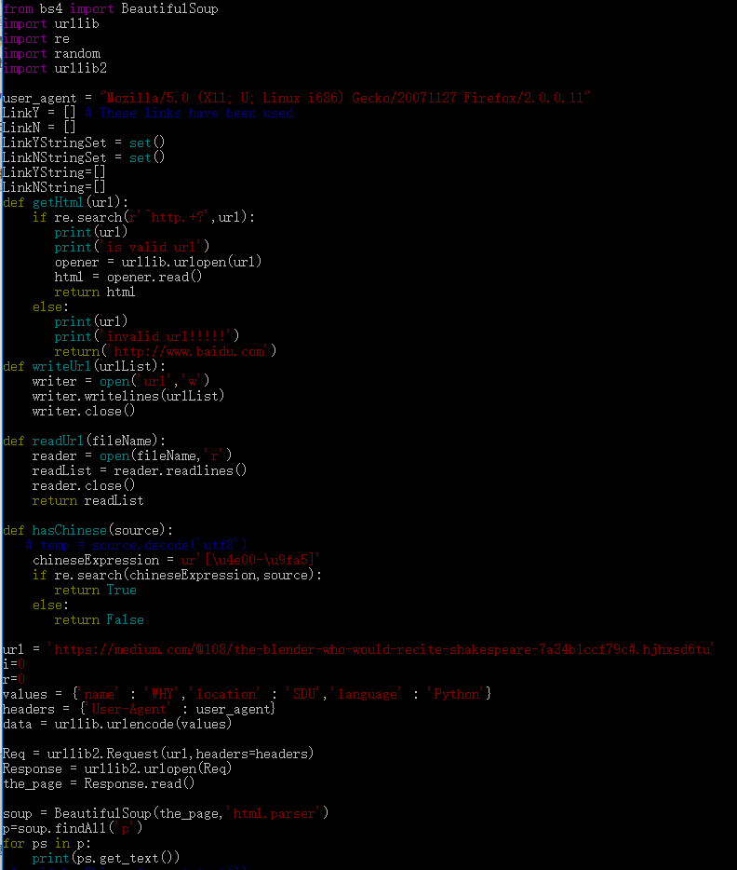
Figure 1: Python crawler
Some of the codes can be found in Figure 1.
- Conclusion
In this report, two hidden topic discovery techniques developed by earlier researcher were introduced, which are LSA and pLSA. In addition, some machine learning algorithms were applied to train the models, like k-means clustering and EM Algorithm. To discover the possibility to improve these models, concepts of information entropy and term frequency – inverse document frequency(TF-IDF) were applied to filter the data sets. The limitations of the models were also analysed, and possible solutions to improve this were given.

Reference List (include section headings)
Books
[1] S. Deerwester, S. T. Dumais, G. W. Furnas, T. K. Landauer and R. Harshman. Indexing by latent semantic analysis. Journal of the American Society for Information Science 41(6), pp. 391. 1990. Available: http://search.proquest.com/docview/1301252034?accountid=12117.

Periodicals and academic journals articles
[2] J. S. Marsland, "On the effect of ionization dead spaces on avalanche multiplication and noise for uniform electric fields", J. Appl. Phys. vol. 67, no.4, pp. 1929 – 1933, Feb. 1990, DOI: 10.1063/1.345596
Conference articles (if any)
[3] J. S. Marsland, “Resonance effects on gain and noise in avalanche photodiodes”, in 2nd Int. Conf. on Optical and Optoelectronic Properties of Materials and Applications, London, England, 2007, pp. 514 – 518, DOI: 10.1007/s10854-008-9714-1
Patents, Standards, Theses, Unpublished (if any)
[4] J. Bardeen, W. Shockley, W. Brattain, “Three-electrode circuit element utilizing semiconductive materials”, US Patent 2524033 A, October 3, 1950.
[5] J. S. Marsland, "Experimental and theoretical ionization coefficients in semiconductors", PhD dissertation, Dept. Electronic & Elec. Eng., Univ. of Sheffield, Sheffield, UK, 1988.
Online material
[6] The University of Liverpool. (2015/16) CoPA appendix L: Academic Integrity Policy [online]. Available: https://www.liv.ac.uk/media/livacuk/tqsd/code-of-practice-on-assessment/appendix_L_cop_assess.pdf (accessed 26th September 2016)
[7] D. Graffox. (2009 Sept.) IEEE Citation Reference [online]. Available: http://www.ieee.org/documents/ieeecitationref.pdf (accessed 26th September 2016)

Appendix 1. The specification report form.

Appendix 2.

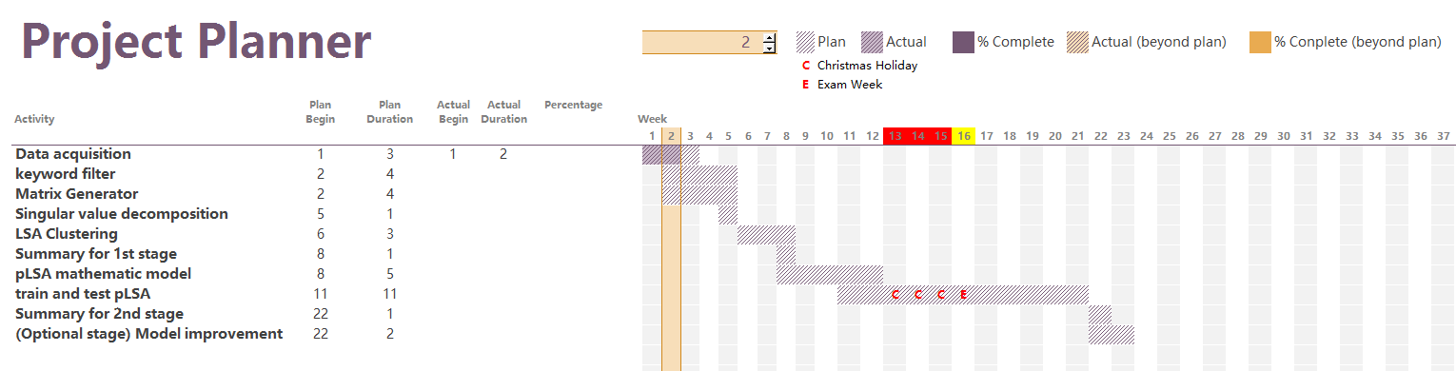
Appendix 3. The risk assessment form.

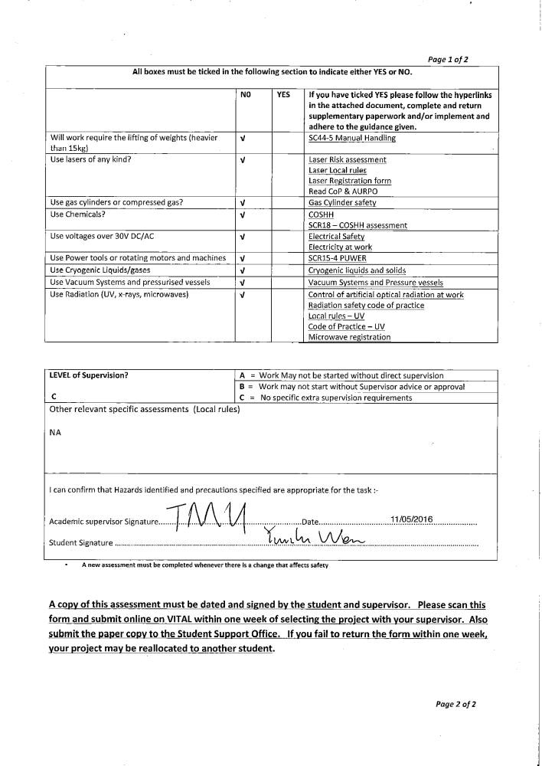
Appendix 4. Ethical approval questionnaire.



